# FLOW REVERSAL INTEGRATION DESGIN

For the flow reversal phase of the project we will need 1 outbound integration process and 3 inbound integration processes.

Outbound

* an outbound integration process triggered on approval for data maintained in STEP required to be send to Infoflo

Inbound

* an inbound integration process for Infoflo to return certain elements on product creation
* a limited daily inbound integration process for the few data elements which will remain under Infoflo’s control and needed in STEP
* a full ad-hoc product inbound integration for
  + when an archived product needs to be revived and re-integrated back to STEP
  + when item type is changed in Infoflo from non-PIM type to PIM type

## On approval STEP -> Infoflo integration (outbound)

**STEP Object Types to monitor**:

* Package Codes (Bag Code, Bundle Code, Carton Code, Coil Code, Crate Code, Misc Code, Pallet Code, Rack Code, Reel Code, Truck Code, Unit Code),
* Packages (Bag, Bundle, Carton, Coil, Crate, Misc, Pallet, Rack, Reel, Truck, Unit),
* Products (Product and Obsolete Product)
* Tariff codes and Dangerous goods codes entities

**Special Pre-Processor Rule** : On product or obsolete product update, referenced-by packages have to be fetched and included in XML.

**Configuration :** Set allow inheritance to Yes, so that package dimensions are blank if they are not overwriting the package code dimensions.

**Mechanics :**

Anytime a product will be (partially) approved in STEP it will be passed to an outbound integration endpoint who will pass it to a REST API service. This service will place the integration message in a controller queue to ensure the messages are processed in order, especially in case of error. The integration messages will be pushed to Infoflo and processed by a validation service (replicating validation logic of Infoflo BOM3000) before data is written into item master (Unidata DB).

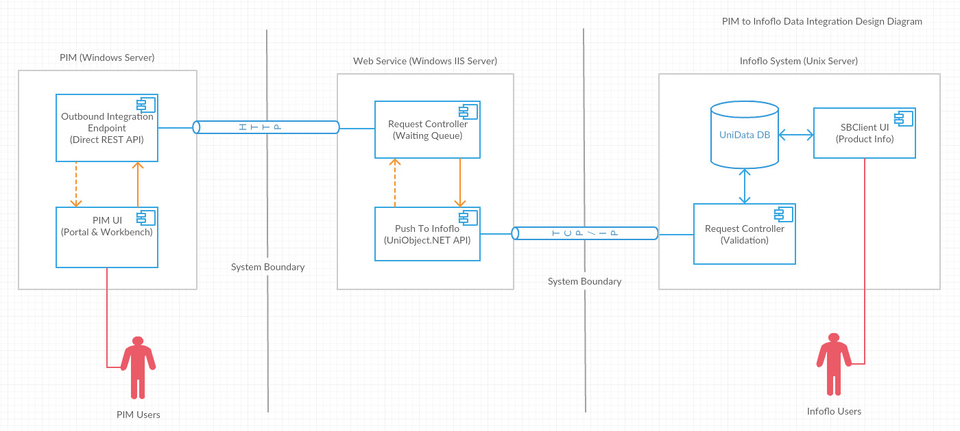

Error handling will be primarily the responsibility of the service taking integration messages out of the queue and into the Infoflo validation service. Only if Infoflo validation succeeds shall the next integration message be processed. If Infoflo integration fails … TBC

**Product Creation :**

In the case an outbound integration call contains a product with no CPN value, meaning a product not yet existing in Infoflo Item Master, a few more things need to happen

* A new Infoflo Item Master record needs to be created. For all fields not provided by STEP, a default value needs to be set. See  « Item Master Mapping.xlsx »
* One or as many record as plant sources have been entered for new product need to be created in the product workbench master table (see Infoflo Modifications design)
* Once created, CPN and UPC need to be returned to STEP via inbound integration (see next section)

## Product creation Infoflo -> STEP integration (inbound)

Anytime a new product request** from STEP is processed by Infoflo, Infoflo needs to send back its internal CPN and the computed UPC code. Right after the product is created in item master table, Infoflo should return the CPN and UPC to STEP using a REST API call. This STEP inbound integration endpoint will use a REST API to listen to events every 1 minute.

CPN and UPC attributes in STEP should be setup with Externally Maintained = Yes, so nothing needs to be approved in this inbound integration.

** : Actually, any outbound integration from STEP to Infoflo shall use CPN as the key for Infoflo to know which product needs to be updated. If CPN is missing, Infoflo will create a new item.

## Limited daily Infoflo -> STEP integration (inbound)

This integration will run as a scheduled job in Infoflo. It will result in the generation of XML files in a STEP hotfolder. The XML files required are

* One file per product with
  + Shipping weight
  + ABC corporate code
  + HasCosting flag
  + Product-Companies : all pricing data, no brand, need currency definition in LOV section
  + Product-Sources (supply-chain, boms and buy cards) : all data, need country definition in entity section
* One file with complete item product line hierarchy

The product files need to be generated only for products with modifications on data elements included in the file (delta mechanism).

Errors in this process will be handled by emails, either from Infoflo if error in creating the XML files or from STEP if error loading XML file.

## Full ad-hoc Infoflo -> STEP product integration (inbound)

Full product data integration is required for 2 cases. One case – item type change – needs to call this integration as a function with a product code or CPN as parameter, and another – archived product revival – needs to run integration from Infoflo command line for one product or a list of products.

This full ad-hoc product integration will be very similar to the existing inbound integration procedure that was developed in the first phase of the project. Differences to take into account :

* Should always treat the product as new
  + No need for replacement rules in xml header
  + No need for delta mechanism
* Some legacy fields will not be included
  + Catalog number and OEM number
  + Product description attributes, incl. brand
  + Duplicate reason code
  + UNSPSC and IGCC categories
  + Country of origin
* Product Line and Brand classifications are not required. Product line because another integration will take care of sending the whole hierarchy to PIM, brand because brands won’t be integrated (see above).
* Tariff Code, Dangerous Goods Code, Country entities can be removed. To be verified : assumption is integration will complete with errors if product refers to an unknown tariff code and/or dg code but product will be created just with empty tariff code / dg code.
* Package Code product object can be removed.
* Package Identifier value can be removed from LOV section. If PI is not defined in PIM then it should be rejected.